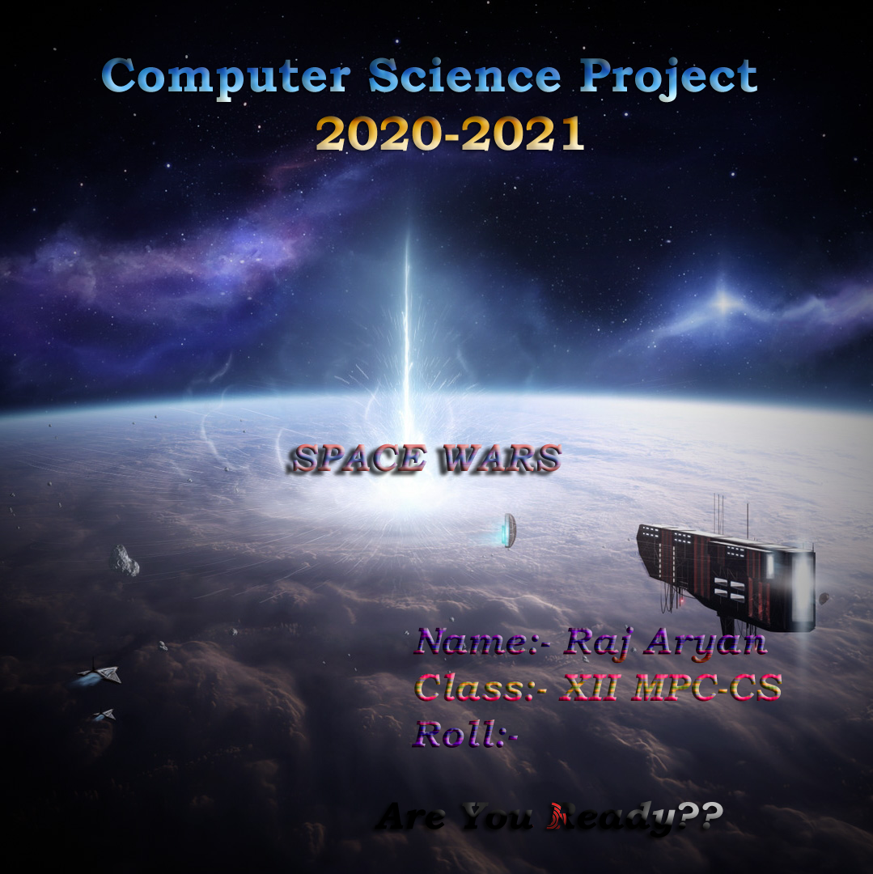

**SRI SATHYA SAI HIGHER SECONDARY SCHOOL**

**VIDYAGIRI, PRASANTHI NILAYAM – 515134**

**CERTIFICATE**

REGD. NO: ……………………

*CERTIFIED THAT THIS IS A BONAFIDE WORK DONE BY ………………………. IN THE AISSCE COURSE IN THE SUBJECT OF ………………………… DURING THE ACADEMIC YEAR 2020-21.*

*THIS PROJECT IS SUBMITTED FOR THE PRACTICAL EXAMINATION CONDUCTED BY CENTRAL BOARD FOR SECONDARY EDUCATION IN MARCH* ***2021****.*

***DATE:***

**PRINCIPAL**

**INTERNAL EXAMINER EXTERNAL EXAMINER**

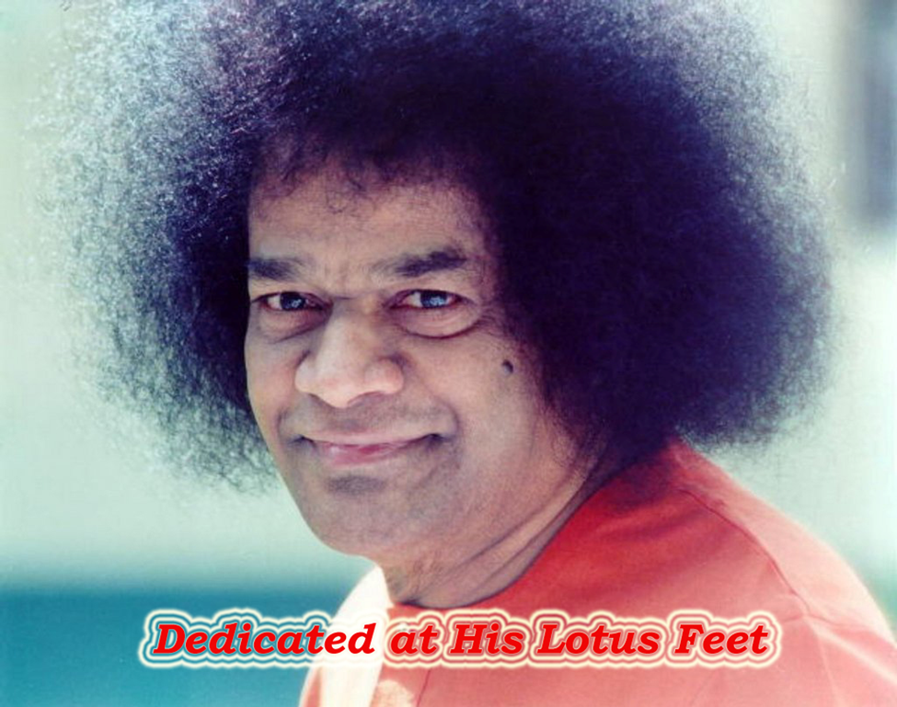

**ACKNOWLEDGEMENTS**

IT’S **HE** WHO GAVE ME STRENGTH. IT’S **HE** WHO GUIDED ME. IT’S BECAUSE OF WHOM I HAVE DONE THIS. TO THE ULTIMATE PROGRAMMER OF OUR LIVES, I PLACE MY GRATITUDE.

I WOULD LIKE TO THANK **SRI VENKATESWAR PRUSTY SIR**, THE EMBODIMENT OF SUPPORT AND TEACHING, FOR HIS CONCERNS, GUIDANCE AND CORRECTING ME THROUGHOUT.

I WOULD LIKE TO THANK **THE PRINCIPAL, SRI SHIVARAMAKRISHNIAH**, FOR THE FACILITIES, PROVIDED TO MAKE MY GAME A REALITY

MY PARENTS, WHO ARE MY PILLAR OF STRENGTH, I WOULD LIKE TO THANK THEM FOR THEIR CARE AND TIME.

LAST BUT NOT THE LEAST, MY FRIENDS AND CLASSMATES FOR THEIR HELP AND SUPPORT.

CONTENTS

AIM

INTRODUCTION

THEORY

IMPLEMENTATION

PROGRAM CODE

SCREENSHOTS

FUTURE ENHANCEMENTS

BIBLIOGRAPHY

AIM

TO DEVELOP THE GAME SPACE WARS

USING PYTHON AND ITS LIBRARIES

INTRODUCTION

THE GAMING INDUSTRY HAS UNDERGONE A SUBSTANTIAL EVOLUTION SINCE THE 1970s AND HAS MOVED FROM A FRINGE ACTIVITY INTO THE MAINSTREAM.IN 1971, THE ARCADE GAME “COMPUTER SPACE” WAS RELEASED AND WAS FOLLOWED UP BY ATARI INC’S FIRST COMMERCIALLY SUCCESSFUL VIDEO GAME, ‘PONG’.THE INDUSTRY HASN’T LOOKED BACK, THE LATEST “FAR CRY 5”, IS THE LIVING TESTAMENT TO THIS.

THEN ROSE THE CONCEPT OF “INDIE GAMES”, i.e. INDIVIDUALLY DEVELOPED GAMES, WHICH IS THE SOUL AND BRAINCHILD OF A SINGLE PERSON. IT TAKES REAL TALENT AND PERSEVERANCE TO DEVELOP THE GAME AS IT IS ONLY ONE PERSON WORKING ON IT SO, IS VERY TIRESOME. ONE SUCH INDIE GAME IS MY GAME “SPACE WARS”. IT IS THE REMAKE OF THE 1978 SUPER HIT AND COMMERCIALLY SUCCESSFUL GAME SPACE INVADERS. IT WAS MADE POSSIBLE BY USING THE PYTHON’S GMING MODULE, PYGAME.

THEORY

THE GAME IS SET AGAINST FOLLOWING BACKDROP. THIS IS THE YEAR 2200. THE EARTH IS NO LONGER OUR HOME. HUMANS HAVE NOW BECOME INTERPLANETARY SPECIES. WE LIVE IN SPACE COLONIES. BUT THERE IS DANGER EVERYWHERE. ON NUMEROUS OCCASIONS, THESE SPACE COLONIES HAVE BEEN ATTACKED BY ALINES. AN ORGANISATION CALLED” **SPACE PATROL DELTA** “CAME INTO BEING TO PROTECT THE HUMANS.

THE PLAYER IN THE GAME IS A COMMISSIONED OFFICER OF THE SPD.HIS COLONY WAS UNDER ATTACK AND HIS COMRADES WENT DOWN FIGHTING. IT IS NOW, HIM VERSUS THE ALIENS. AT ANY COST HE HAS TO STOP THEM.

ALIENS HAVE REPLICATION TECHNOLOGY SO EVERY TIME A WAVE GETS WIPED OUT NEW WAVE GETS GENERATED WITH INCREASED NUMBER OF ENEMIES. THERE IS NO END TO IT!!

IMPLEMENTATION

THE PYGAME MODULE FROM PYTHON LIBRARY WAS USED TO CREATE THE GAME.

TO AVOID CONFUSION AND MAKE THE PROGRAM MORE EFFICIENT, OBJECT ORIENTED PROGRAMMING AND MODULAR APPROACH WAS USED.

THERE ARE CLASSES AND FUNCTIONS DEFINED TO EASE THE PROGRAM’S COMPLEXITY.

THE GAME DESIGN IS SIMPLE. IT WAS DESIGNED KEEPING IN VIEW THE FOLLOWING:

* HANDLING ALL SORTS OF COLLISIONS BETWEEN THE ALIEN BULLETS AND THE PLAYER AND THE PLAYER BULLETS AND THE ALIENS.
* HANDLING THE STATE OF ALL OBJECTS OF DIFFERENT CLASSES OF ALIENS, BULLETS, PLAYER, AND GAME.
* HANDLING ALL IMAGES, SOUND AND TEXT FILES ASSOCIATED WITH THE GAME.
* HANDLING THE MAIN MENU, INSTRUCTIONS ETC.

FUNCTIONS:-

* Def game_menu():

This function is responsible for displaying the starting screen of the game, the first thing that user interacts within the game. It calls button() for showing buttons on the starting screen.

* Def text_objects(text,x,y,colour):

This function displays text onto the pygame window

at the specified (x,y) in the specified colour.

* Def button **(msg,x,y,active_colour,inactive_colour,length,height,action):**

This function is responsible for providing buttons with their functionality. Based on a condition, it first checks whether the user is hovering the mouse over the rectangle of the button if so it changes the colour of the button to a brighter one otherwise it does nothing. In case the left mouse button is clicked, according to the action assigned to that button it performs the particular task. It calls text_objects() to display text on the buttons.

*Classes:-*

All the alien classes have the same structure and the same is true for all the bullet classes. Apart from these, there is a user class and a game class for the ease of handling.

* **User:**

The user can move only along x-axis using the arrow keys. He has shooting abilities which he uses to defend as well as attack.

**class user:**

Def __init__(self):

The constructor of the user class. It loads the   
 user image and assigns a set of coordinates for   
 the user. It also initializes user_bullets list,   
 user health variable, x_change, and a   
 cooldown_count variable which comes in handy in   
 designing shooting mechanic for the player.

Def movement(self,userInput):

This function is responsible for moving the user   
 on screen. It checks for key presses and   
 accordingly moves the user. It also makes sure   
 that the user does not go off the screen.

Def eliminate(self):

Changes the abscissa of the user to 1000. It is   
 helpful when it is required to display the player   
 off the screen.

Def cooldown(self):

This function is used to limit the shooting   
 capabilities of the user based on a condition.

Def is_collision(self,aliens_list):

This function checks for the collision between   
 the alien bullets and the user. If there is a   
 collision, it returns true and removes that   
 particular alien bullet from the list otherwise it   
 returns false.

Def shoot(self,userInput):

This function handles the shooting mechanic of the   
 player. Based on a particular keypress, it creates   
 objects of user bullet class, appends it to user   
 bullets list then using a loop fires them and also   
 plays the shooting sound.

Def health_status(self):

This function draws and updates the health bar of   
 the player based on the user health variable.

* **User Bullet:**

User bullet moves only along the positive direction of the y-axis.

**class UserBullet():**

Def __init__(self,x,y):  
 The constructor of user bullet class. It loads the   
 image of the user bullet and assigns an initial   
 position for the bullet. It also initializes   
 x_change and y_change for user bullet

Def draw_bullet(self,x,y):

This function blits the bullet image at the   
 specified coordinates.

Def off_screen(self):

This function checks if the bullet is not   
 present on the game screen. If yes, it returns   
 true.

Def movement(self):

This function is responsible for moving the user   
 bullet on the screen. It calls the draw_bullet()   
 to accomplish it.

* **Aliens:**

The aliens can move in both directions. Like user, both types of aliens in the game have shooting abilities. But the harm that their respective bullets does to the user’s health is different.

**class Alien1():**

Def __init__(self):

The constructor of Alien1 class.It loads the   
 alien_1 image and assigns an initial set of   
 coordinates for the alien_1. It also initializes   
 bullets list, x_change, y_change,max_bullets,

fire_chance,and prob_to_fire variables

which are used in designing the shooting   
 mechanic for the alien.

Def movement(self):

This function is responsible for making sure that   
 aliens do not go out of the screen and for   
 moving them in a particular fashion

Def eliminate(self):

This function changes the ordinate of every   
 alien present in the alien_type_1_list object to 2000.

Def shoot(self):

This function is responsible for making the aliens   
 shoot the bullets based on a condition. If the   
 condition is true, it creates an object of   
 Alien1_bullet and appends it to bullets list for   
 each alien. And then loops through the bullets list   
 to move them and if they are off-screen, it   
 eliminates them.

Def is_collision(self):

This function checks the collision of the user   
 bullets with the alien. If it detects a collision, it   
 returns true and removes that particular bullet   
 from the user bullets list otherwise it returns   
 false.

Def draw_enemy(self):

This function blits the alien at the specified x, y   
 coordinate.

**class Alien2():**

Same as the Alien1 class.

* **Alien Bullets:**

Alien bullets move along the negative direction of the y-axis.

**class Alien1_Bullet():**

Def __init__():

This is the constructor of Alien1_Bullet class. It   
 loads the image of Alien1 bullet and also assign an   
 initial x,y coordinates. It also initializes x_change   
 and y_change variable for alien1 bullet.

Def draw_bullet(self,x,y):

This function blits the alien1 bullet image at the   
 specified x,y coordinates.

Def off_screen(self):

This function checks whether the alien1 bullet has   
 crossed a certain point on the screen. If yes, it   
 returns true.

Def movement(self):

This function is responsible for moving the alien1   
 bullet on the screen. It calls the draw_bullet() to   
 accomplish the task.

**class Alien2_Bullet():** Same as Alien1_Bullet class.

* **Game:**

A game class was necessary to handle the entities which are a fundamental part of a game like a score, high score, levels and for better execution of functions like updating level, handling game over condition etc.

**class Game():**

Def __init__(self):  
 This is the constructor of the game class. It   
 initializes variables like num_of_enemies, level,   
 score, high score,color_list,user_shooting_lim,

user_dealth_del

Def read_highscore(self):

This function is used to read the high score   
 from a the text file and store it in a variable.

Def update_highscore(self):

This function is used to update the high score.

Def show_score(self):

This function displays score, high score and current   
 level onto the screen.

Def game_over(self):

This function handles everything that is to be   
 done after the game is over. It updates the high

score, eliminates the user and the aliens from the   
 screen and displays game over message onto the   
 screen.

Def level_update(self, alien_type_1_list, alien_type_2_list):

This function is used to update the level. Based   
 on a condition, which if true, it updates the level   
 and certain other parameters that need to be   
 updated every time the user jumps a level.

Game Loop:

The main game loop consists of two while loops. One while loop gives the game it’s menu option. When the condition for the menu loop becomes false, it redirects the user to the game loop.

It is in the game loop where all the entities of the game are updated and events are handled. The alien objects are also created inside the game loop itself. The functions for movement, attack from each class are called in the main game loop. The collision of objects is checked in this loop and what is to be done after the collision is also defined in the main game loop.

The game loop is the backbone of the game.

**Program Code:**

SpaceWar.py:-

**import** pygame  
**import** random  
**from** pygame **import** mixer  
  
pygame.init()  
  
*# background*screen = pygame.display.set_mode((800, 600))  
bg_img = pygame.image.load(**"background.jpg"**)  
background = pygame.transform.scale(bg_img, (800, 600))  
start_pic = pygame.image.load(**"starting_image copy.jpg"**)  
  
*# background music*mixer.music.load(**"background.wav"**)  
mixer.music.play(-1)

*# font object*font = pygame.font.Font(**"freesansbold.ttf"**, 32)  
  
*# some colours*bright_green = (0, 255, 0)  
green = (0, 175, 0)  
bright_red = (255, 0, 0)  
red = (175, 0, 0)  
black = (0, 0, 0)  
  
running = **True***# title and icon*pygame.display.set_caption(**"Space Wars"**)  
icon = pygame.image.load(**"project_icon.png"**)  
pygame.display.set_icon(icon)  
  
*# Images:*player_img = pygame.image.load(**'rocket_1.png'**)  
enemy1_img = pygame.image.load(**'alien_1.png'**)  
enemy2_img = pygame.image.load(**'ufo.png'**)  
player_bullet_img = pygame.image.load(**'user_bullet.png'**)  
enemy1_bullet_img = pygame.transform.scale(pygame.image.load(**"alien_bullet_2.png"**), (32, 32))  
enemy2_bullet_img = pygame.transform.scale(pygame.image.load(**"alien_bullet_1.png"**), (32, 32))  
instructions_img = pygame.transform.scale(pygame.image.load(**"how_to_play.png"**),(800, 600))  
mini_ship = pygame.transform.scale(pygame.image.load(**"rocket_1.png"**), (32, 32))  
  
*#--------------------------------Classes---------------------  
# Game control parameters***class** Game():  
  
 **def** __init__(self):  
 self.num_of_enemies = 2  
 self.level = 1  
 self.score = 0  
 self.high_score = **''** self.color_list = (random.randint(0, 255),random.randint(0, 255),   
 random.randint(0, 255))  
 self.user_shooting_lim =200  
 self.user_health_del=4  
  
 **def** level_update(self, alien_type_1_list, alien_type_2_list):  
 **if** len(alien_type_1_list) == 0 **and** len(alien_type_2_list) == 0:  
 self.score += 25  
 self.level += 1  
 self.num_of_enemies += 2  
 self.user_shooting_lim-=2  
 self.user_health_del+=4  
  
 **def** read_highscore(self):  
 **with** open(**"highscore.txt"**, **"r"**) **as** f:  
 self.high_score = f.read()  
  
 **def** update_highscore(self):  
 **with** open(**"highscore.txt"**, **"w"**) **as** f:  
 f.write(str(self.high_score))  
  
 **def** show_score(self):  
 score = font.render(**"Score :"** + str(self.score),   
 **True**,(255, 255, 255))  
 screen.blit(score, (10, 10))  
 hiscore = font.render(**"High Score :"** +   
 str(self.high_score), **True**, (18, 208, 18))  
 screen.blit(hiscore, (540, 500))  
  
 level = font.render(**"Level:"** + str(self.level), **True**, (255, 1, 1))  
 screen.blit(level, (40, 500))

**def** game_over(self):  
 **if** self.score > int(self.high_score):  
 self.high_score = self.score  
 self.update_highscore()  
 alien.eliminate()  
 ship.eliminate()  
 ufo.eliminate()  
 screen.fill((0, 0, 0))  
 text_objects(**"GAME OVER"**, 200, 250, red)  
  
  
game = Game()

*# Player***class** user:  
 x_change: int  
  
 **def** __init__(self):  
 self.Img = player_img  
 self.x = 370  
 self.y = 480  
 self.x_change = 0  
 self.bullets = []  
 self.cooldown_count = 0  
 self.health = 240  
  
 **def** movement(self, userInput):  
 self.x_change = 0  
 **if** userInput[pygame.K_LEFT]:  
 self.x_change = -1  
 **if** userInput[pygame.K_RIGHT]:  
 self.x_change = 1  
 *# checking for boundaries while steering spaceship* **if** self.x <= 0:  
 self.x = 0  
 **if** self.x >= 736:  
 self.x = 736  
 self.x += self.x_change  
  
 **def** draw_player(self):screen.blit(self.Img, (self.x, self.y))  
  
 **def** eliminate(self):  
 self.x = 1000  
  
 *# so that ship does not fire infinte many bullets* **def** cooldown(self):**if** self.cooldown_count >= game.user_shooting_lim:  
 self.cooldown_count = 0  
 **elif** self.cooldown_count > 0:  
 self.cooldown_count += 1  
  
 **def** is_collision(self, aliens_list):  
 **for** alien **in** aliens_list:  
 **for** alien_bullet **in** alien.bullets:  
 **if** (self.x < alien_bullet.x < self.x + 64) **and** (self.y < alien_bullet.y < self.y + 64):alien.bullets.remove(alien_bullet)  
 **return True  
 else**:  
 **return False  
  
 def** shoot(self, userInput):  
 self.cooldown()  
 **if** userInput[pygame.K_SPACE] **and** (self.cooldown_count == 0):  
 bullet = UserBullet(self.x, self.y)  
 self.bullets.append(bullet)bullet_sound = mixer.Sound(**"laser.wav"**)  
 bullet_sound.play()  
 self.cooldown_count = 1  
 **for** bullet **in** self.bullets:bullet.movement()  
 **if** bullet.off_screen():self.bullets.remove(bullet)  
  
 **def** health_status(self):  
 pygame.draw.rect(screen, bright_red, (500, 10, 240, 20))  
 pygame.draw.rect(screen, bright_green, (500, 10,   
 self.health, 20))  
 screen.blit(mini_ship, (485 + self.health, 10))

*# enemy 1***class** Alien1():  
 **def** __init__(self):  
 self.Img = enemy1_img  
 self.x = random.randint(0, 735)  
 self.y = random.randint(50, 150)  
 self.x_change = 1  
 self.y_change = 10  
 self.bullets = []  
 self.max_bullets = 1  
 self.fire_chance = random.random()  
 self.prob_to_fire=0.4  
  
 **def** movement(self):  
 **if** self.x <= 0:  
 self.x_change = 1.  
 self.y += self.y_change  
 **elif** self.x >= 736:  
 self.x_change = -1.  
 self.y += self.y_change  
 self.x += self.x_change  
  
 **def** draw_enemy(self):  
 *#pygame.draw.rect(screen, black, (self.x, self.y, 64, 64), 1)* screen.blit(self.Img, (self.x, self.y))

*# blits the alien off the screen after the game is over* **def** eliminate(self):  
 **for** self **in** alien_type_1_list:  
 self.y = 2000  
  
 **def** shoot(self):  
 **if** (self.fire_chance <= self.prob_to_fire) **and   
 (**len(self.bullets) <= self.max_bullets):  
 alien_bullet = Alien1_Bullet(self.x, self.y)  
 self.bullets.append(alien_bullet)  
 **for** alien_bullet **in** self.bullets:  
 alien_bullet.movement()  
 **if** alien_bullet.off_screen():  
 self.bullets.remove(alien_bullet)  
  
 **def** is_collision(self):  
 **for** bullet **in** ship.bullets:  
 **if** (self.x < bullet.x < self.x + 64) **and**

(self.y + 2 <bullet.y < self.y + 64):ship.bullets.remove(bullet)  
 **return True  
 else**:  
 **return False**

*# Alien_1 Bullet***class** Alien1_Bullet():  
  
 **def** __init__(self, x, y):  
 self.Img = enemy1_bullet_img  
 self.x = x + 5  
 self.y = y + 50  
 self.x_change = 0  
 self.y_change = 1  
  
 **def** draw_bullet(self,x,y):  
 screen.blit(self.Img, (self.x, self.y))  
  
 **def** off_screen(self):  
 **if** self.y >= 550:  
 **return True  
  
 def** movement(self):  
 *# pygame.draw.rect(screen, black, (self.x, self.y, 45, 40), 1)* self.draw_bullet(self.x, self.y)  
 self.y += self.y_change  
  
  
*# Enemy 2***class** Alien2():  
 **def** __init__(self):  
 self.Img = enemy2_img  
 self.x = random.randint(0, 735)  
 self.y = random.randint(50, 150)  
 self.x_change = 1  
 self.y_change = 10  
 self.bullets = []  
 self.max_bullets = 1  
 self.fire_chance = random.random()  
 self.prob_to_fire=0.4  
  
 **def** movement(self):  
 **if** self.x <= 0:  
 self.x_change = 2  
 self.y += self.y_change  
 **elif** self.x >= 736:  
 self.x_change = -2  
 self.y += self.y_change  
 self.x += self.x_change

**def** draw_enemy(self):screen.blit(self.Img, (self.x, self.y))

*# blits the alien off the screen after the game is over*

**def** eliminate(self):  
 **for** self **in** alien_type_2_list:  
 self.y = 2000  
  
 **def** shoot(self):  
 **if** (self.fire_chance <=self.prob_to_fire) **and** len(self.bullets) <= self.max_bullets:  
 ufo_bullet = Alien2_Bullet(self.x, self.y)  
 self.bullets.append(ufo_bullet)  
 **for** ufo_bullet **in** self.bullets:  
 ufo_bullet.movement()  
 **if** ufo_bullet.off_screen():  
 self.bullets.remove(ufo_bullet)  
  
 **def** is_collision(self):  
 **for** bullet **in** ship.bullets:  
 **if** (self.x < bullet.x < self.x + 64) **and** (self.y   
 + 2 <bullet.y < self.y + 64):  
 ship.bullets.remove(bullet)  
 **return True  
 else**:

**return False**

*# Alien_2 bullet***class** Alien2_Bullet():  
 **def** __init__(self, x, y):  
 self.Img = enemy2_bullet_img  
 self.x = x + 5  
 self.y = y + 50  
 self.x_change = 0  
 self.y_change = 1  
  
 **def** off_screen(self):  
 **if** (self.y >= 550):  
 **return True  
  
 def** draw_bullet(self, x, y):  
 screen.blit(self.Img, (self.x, self.y))  
  
 **def** movement(self):  
 self.draw_bullet(self.x, self.y)self.y += self.y_change

*# User Bullet***class** UserBullet():  
  
 **def** __init__(self, x, y):  
 self.Img = player_bullet_img  
 self.x = x + 16  
 self.y = y + 10  
 self.x_change = 0  
 self.y_change = 3  
  
 **def** draw_bullet(self, x, y):  
 screen.blit(self.Img, (self.x, self.y))  
  
 **def** off_screen(self):  
 **if not** (self.y >= 0):  
 **return True  
  
 def** movement(self):  
 self.draw_bullet(self.x, self.y)  
 self.y -= self.y_change

*#-------------------------Functions----------------------------------***def** text_objects(text, x, y, colour):  
 **if** text != **"GAME OVER"**:  
 text = font.render(text, **True**, colour)  
 screen.blit(text, (x, y))  
 **else**:  
 over_font = pygame.font.Font(**"freesansbold.ttf"**, 75)  
 text = over_font.render(text, **True**, colour)  
 screen.blit(text, (200, 250))  
  
  
**def** button(msg, x, y, active_colour, inactive_colour, length, height, action=**None**):  
 text_call = **True** mouse = pygame.mouse.get_pos()  
 click = pygame.mouse.get_pressed()  
 *# if the mouse is hovering over the button:* **if (**x + length > mouse[0] > x )**and**

**(**y + height > mouse[1] > y):  
 pygame.draw.rect(screen, active_colour, (x, y, length, height))  
 **if** click[2] == **True and** action != **None**:  
 **if** action == **"inst"**:  
 text_call = **False** screen.fill((0, 0, 0))  
 screen.blit(instructions_img, (0, 0))  
 **if** action == **"quit"**:  
 print(**"quit"**)  
 pygame.quit()  
 quit()  
 **else**:  
 pygame.draw.rect(screen, inactive_colour, (x, y, length, height))  
  
 **if** text_call:  
 text_objects(msg, x + 25, y + 20, black)  
  
  
**def** game_menu():  
 screen.fill((0, 0, 0,))  
 screen.blit(start_pic, (0, 0))  
 font1 = pygame.font.Font(**"freesansbold.ttf"**, 34)  
 text1 = font1.render(**"Right click anywhere on the   
 screen to play"**, **True**, game.color_list)  
 pygame.draw.rect(screen,red,(80,450,700,30),3)  
 screen.blit(text1, (80, 450))  
 pygame.draw.rect(screen, green, (480, 300, 150, 75))  
 pygame.draw.rect(screen, red, (150, 300, 285, 75))  
 button(**'QUIT'**, 480, 300, bright_green, green, 150, 75,   
 **"quit"**)  
 button(**"INSTRUCTIONS"**, 150, 300, bright_red, red, 285, 75,   
 **"inst"**)  
 pygame.display.update()  
  
  
ship = user()  
alien_type_1_list = []  
alien_type_2_list = []

*#--------------------------the main loop---------------------------------*menu = **True  
while** running:  
 #game menu loop  
 **while** menu:  
 **for** event **in** pygame.event.get():  
 **if** event.type == pygame.QUIT:  
 quit()  
 **elif** event.type == pygame.MOUSEBUTTONDOWN:  
 **if** event.button == 1:  
 menu = **False** game_menu()  
  
 screen.fill((0, 0, 0,))  
 screen.blit(background, (0, 0))  
  
 *# Event Handlers:* **for** event **in** pygame.event.get():  
 **if** event.type == pygame.QUIT:  
 running = **False  
 if** event.type == pygame.KEYDOWN:  
 **if** event.key == pygame.K_p:  
 menu = **True**

*# Player:* userInput = pygame.key.get_pressed()  
 ship.movement(userInput)  
 ship.shoot(userInput)  
 ship.health_status()  
 ship.draw_player()  
  
 *# creating enemies object* **if** len(alien_type_1_list) == 0 **and** len(alien_type_2_list) == 0:  
 **for** i **in** range(game.num_of_enemies):  
 alien = Alien1()  
 ufo = Alien2()  
 alien_type_1_list.append(alien)  
 alien_type_2_list.append(ufo)

*# Enemy 1:* **for** alien **in** alien_type_1_list:  
 alien.draw_enemy()  
 alien.shoot()  
 alien.movement()  
 **if** alien.y > 440 **or** ship.health < 0:  
 game.game_over()

*# Collision check of user_bullet with enemy_1:* collision = alien.is_collision()  
 **if** collision:  
 explosion_sound = mixer.Sound(**"explosion.wav"**)  
 explosion_sound.play()  
 game.score += 1  
 alien_type_1_list.remove(alien)

*# Enemy 2:* **for** ufo **in** alien_type_2_list:  
 ufo.draw_enemy()  
 ufo.shoot()  
 ufo.movement()  
 **if** ufo.y > 440 **or** ship.health < 0:  
 game.game_over()

*# Collision check of user_bullet with enemy_2:* ufo_collision = ufo.is_collision()  
 **if** ufo_collision:  
 explosion_sound = mixer.Sound(**"explosion.wav"**)  
 explosion_sound.play()  
 game.score += 2  
 alien_type_2_list.remove(ufo)

*# Collision of enemy_1_bullet with the ship* collision_1 = ship.is_collision(alien_type_1_list)  
 **if** collision_1:  
 ship.health -=game.user_health_del+2  
 *# Collision of enemy_2_bullet with the ship* collision_2 = ship.is_collision(alien_type_2_list)  
 **if** collision_2:  
 ship.health -=game.user_health_del

game.show_score()  
 game.read_highscore()  
 game.level_update(alien_type_1_list, alien_type_2_list)  
 pygame.display.update()

Screenshots:

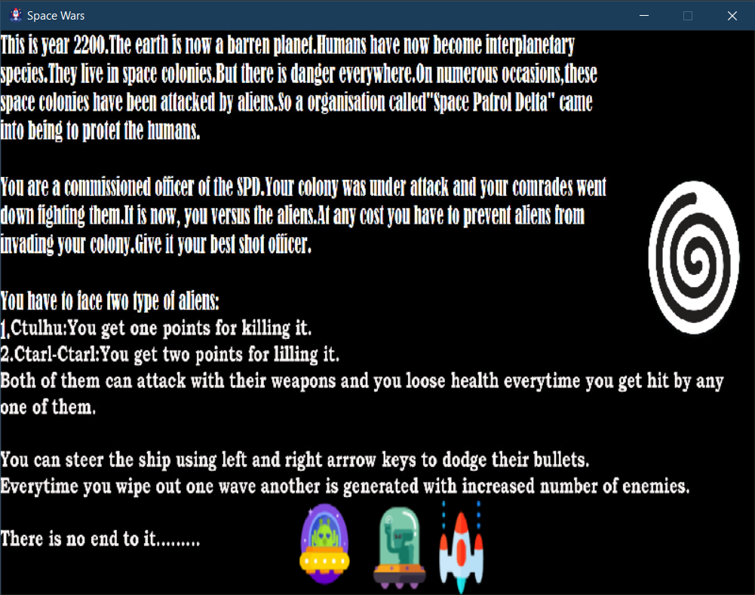

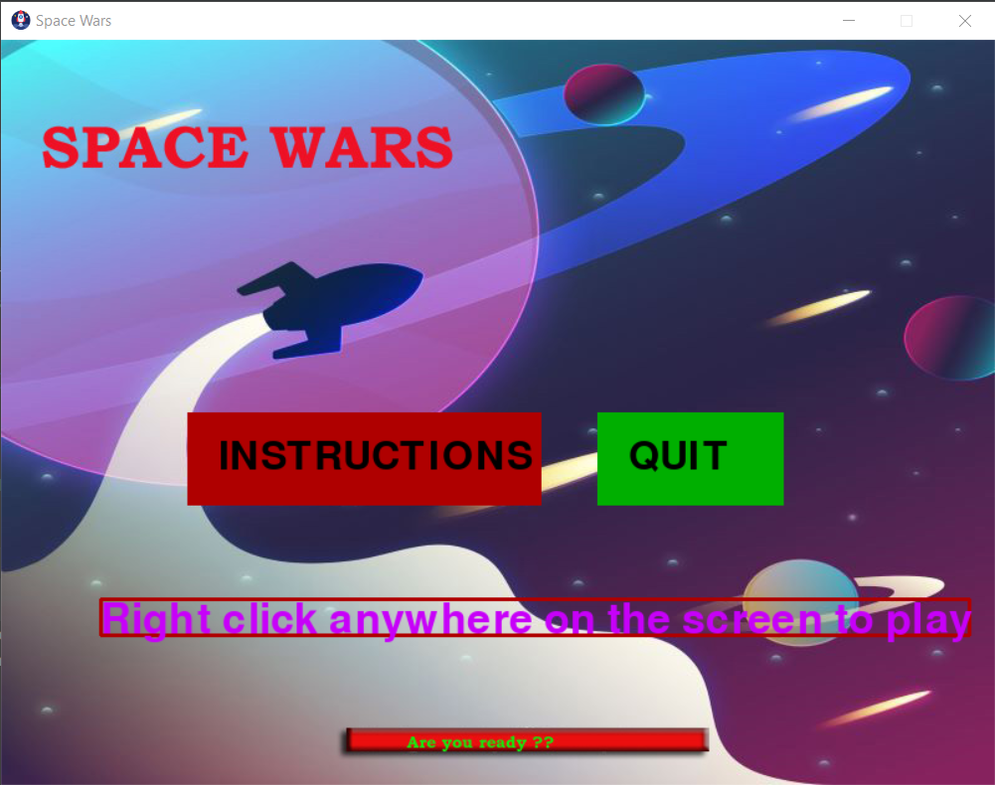

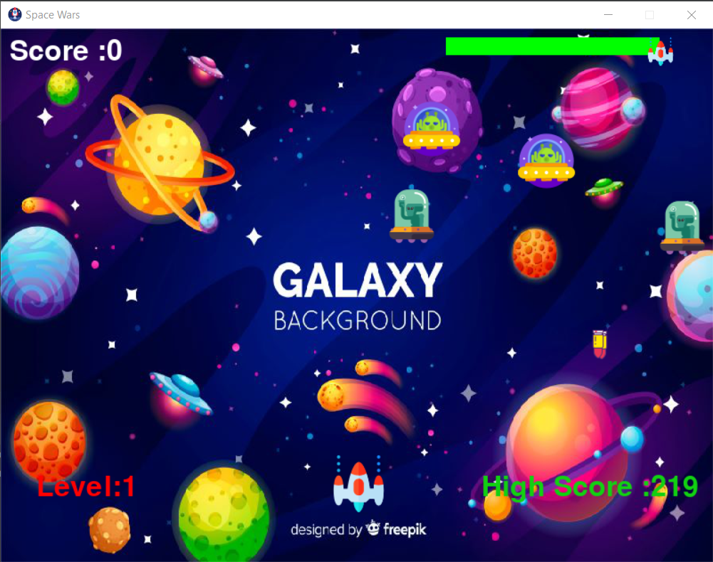

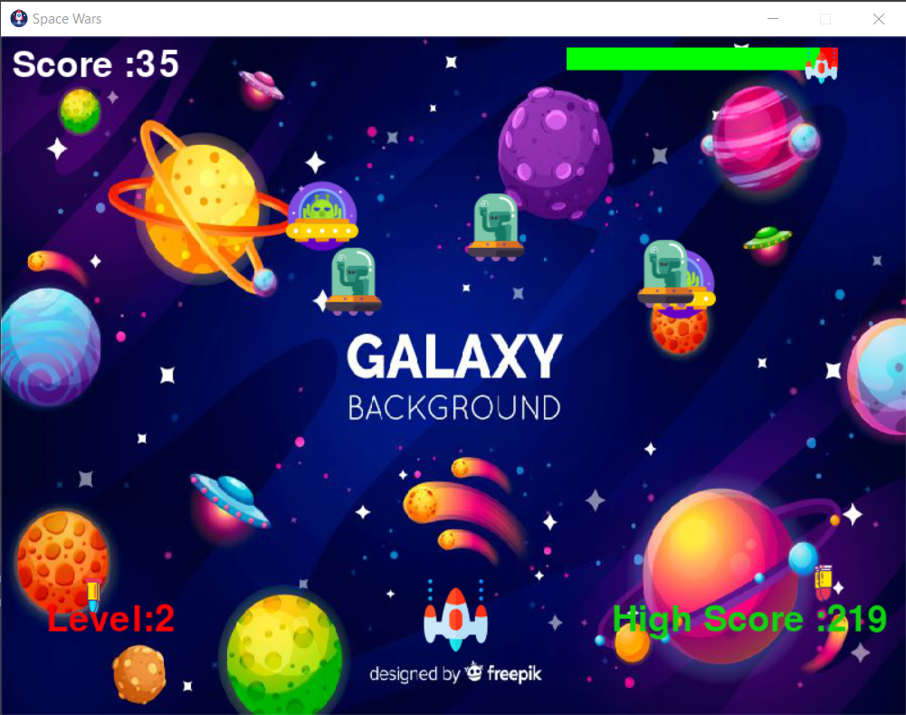

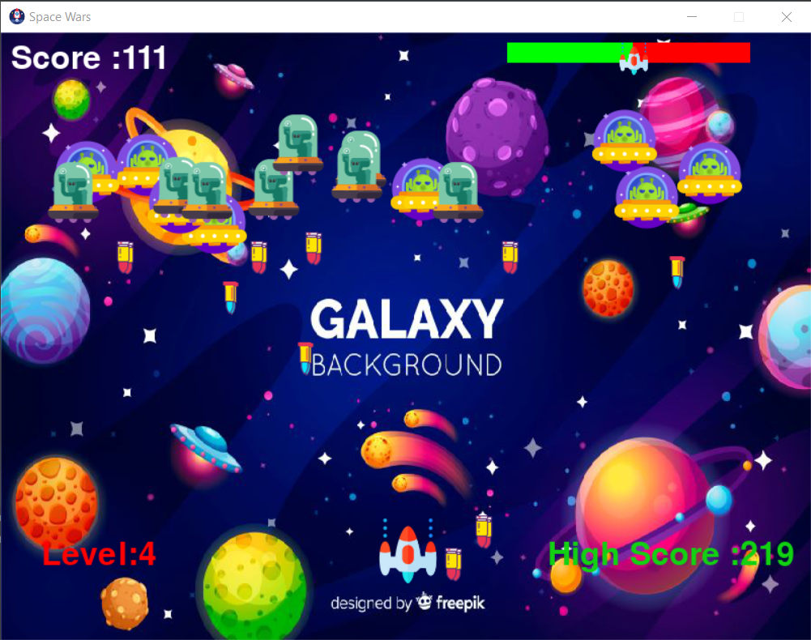

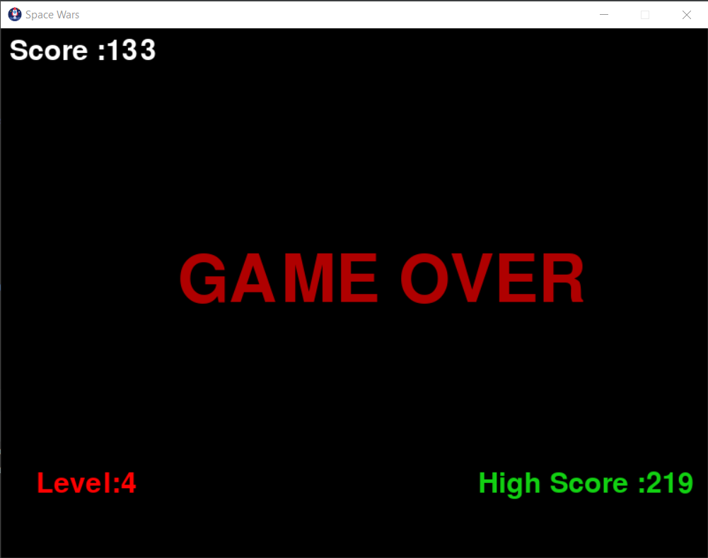

**Future Enhancements:**

* There is no explosion when the bullets hit an object. The explosion can be added to make the game rich in graphics.
* After the game over message is displayed, there can be a restart functionality so that the user does not have to run the code once again.
* There can be a level boss after killing whom the player will officially jump a level. This will make the game more interesting.
* There are no lives for the player as of now. Adding some lives for the player will help the user stay in the game longer and enjoy it to a greater extent.
* The game window is not big enough. As the levels increase, so does the number of enemies and the game screen starts to look crowded. A bigger game window will not only help in solving this problem, but this could be useful for many more things.
* Some more type of aliens can be introduced in the game at different levels.
* The powerups could be included.
* The modular approach will help in making the code more efficient.
* The scoring mechanism needs improvement.

**Bibliography:**

The following sources of knowledge were used while creating this game:

* Making games with Python and Pygame

By A.I. Sweigart

* Code Bucket [You Tube]